**ASSET MANAGEMENT SOFTWARE**

Asset management software is a dedicated application which is used to record and track an asset throughout its life cycle, from procurement to disposal. It provides an organization with information like where certain assets are located, who is using them, how they are being utilized and details about the asset. The asset management software is used for management of both software and hardware assets.

**Asset Management Life Cycle:**

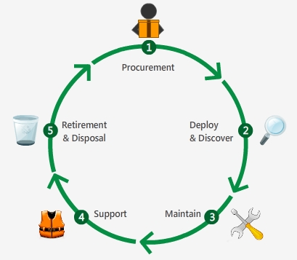

**Procurement**

Create purchase orders

Pre-defined PO workflow

Link to cost (Budgets)

Post-purchase, adding to the assets inventory

**Deploy and Discover**

Deploy the assets

Discover the assets in the network for software and hardware

Add relationship maps

**Maintain**

Schedule scans and get audit history

Complete ownership tracking

Software compliance and license management

Asset depreciation calculations

**Support**

Maintain contracts for assets

Notify technicians of expiry dates

Identify impact through dependency mapping

Software license agreements

**Retirement and Disposal**

Change the state of an asset to expired/disposed

All the software allocated to the disposed asset will get un-allocated